Purpose
To gross and evaluate post-neoadjuvant therapy breast specimens. Proper handling and sampling of these specimen types is critical to adequately identify residual tumor and/or treatment response.
Procedure
- Review the patient’s history in MiChart to determine if they received neoadjuvant therapy. Determine measurements of lesion(s) pre-treatment and post treatment.
- The specimen will be triaged at time of grossing. Check the orientation to determine if it is inked and sectioned correctly. Triaged information should include weight, measurements, and time in formalin (TIF).
  - The specimen should be inked as follows: anterior-superior – blue, anterior-inferior – green, deep/posterior – black, and nipple site (if applicable) – red. Or with standard breast lump ink if it is a lumpectomy specimen.
  - The specimen should be sectioned medial to lateral/lateral to medial.
  - The specimen should have been sectioned at 0.5 cm to 1.0 cm intervals. If not, thin out your sections before continuing to gross.
- Check the skin and nipple for any gross abnormalities and document in the gross description.
- Amputate the nipple, serially section and submit entirely.
- Continue the cuts made during triage, continuing the cuts to about 2mm from skin.
- Determine how many slices you have and document in the gross description.
- Examine each slice. Describe the tumor bed and/or any lesions. Description should include the size, location, distance to margins and nipple, and borders of the tumor bed and/or lesion. Describe any biopsy site/biopsy clips.
- Completely remove the slices from the breast that contain the tumor bed and lay out in order. Take gross photographs.
- Submit a full cross section of tumor bed from slice with the largest dimension of tumor bed (just one full face; do not include trimmed/thinned portion of slice).
- Representative sections from adjacent slices with tumor bed should be submitted.
  - **Contact attending if you have any questions as to what to submit. If you are going to be submitting 30+ blocks on a single mastectomy, please contact attending first to determine what to submit.
- Sections to also submit: Margins closest to tumor bed and/or lesion(s), biopsy site, any other pathological findings, and 1 block for each quadrant.
- Use post-neoadjuvant therapy template

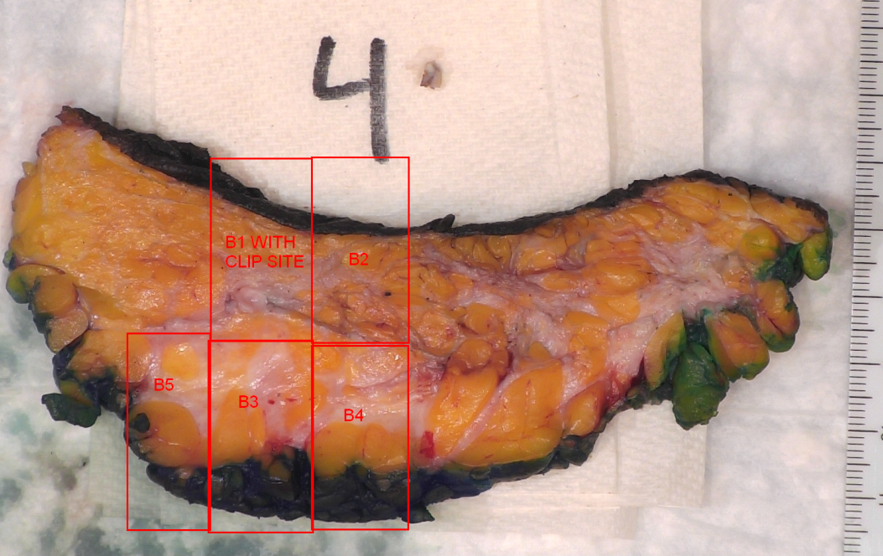
Example of an annotated slice with largest measurement of tumor bed.

Post–Neoadjuvant Therapy Specimens:

Part #:______ “_________________”

Specimen type: __ [Simple Mastectomy, Skin-Sparing Mastectomy, Nipple-Sparing Mastectomy, Modified Radical Mastectomy, Radical Mastectomy]

Post–Neoadjuvant Therapy: __ [Yes/No]
Weight: __
Orientation: __
Measurements: __ cm medial to lateral; __ cm superior to inferior; __ cm anterior to posterior
Skin ellipse: __ cm (measure, describe)
Nipple: __ cm (measure, describe)
Axillary tail: __ cm (measure, describe)

Ink code: Deep surface = black, Anterior-superior surface = blue, Anterior-inferior surface = green, If nipple-sparing: nipple base= red

Preoperative Images Available: __ [Yes/No]

Sectioning: from __ to __
Total number of slices: __

Specimen/Slices sent for Faxitron/X-Ray: __ [Yes/No]
Specimen mapping/photos taken: __ [Yes/No]

Lesions Identified: __[Yes/No], __[Number]lesion(s), __Number of clips:__ Location of clips:___

*If discrete gross tumor with no significant treatment response seen, proceed to a non-neoadjuvant treated specimen:

Pretreatment tumor size (imaging): __
Posttreatment tumor size (imaging): __

Fibrotic tumor bed: __ (describe)
Position/location:
Tumor bed size: __ cm(superior-inferior) x ___ cm (medial-lateral) x ___ cm (anterior-posterior)
Slices: __ to __
Clip Information: Shape____, Slice#___; Magseed slice #
Grossly evident biopsy site: ____ [Yes/No], Slice# __
Distance of fibrotic tumor bed from margins:
__ cm from Anterior-superior surface
__ cm from Anterior-inferior surface
__ cm from Deep surface

The remainder of the uninvolved parenchyma consists of ____% tan-yell adipose tissue and ___% white fibrous tissue.

COMMENT:

Cassette Summary:

Date/Time excised: __
Date/Time into formalin: __
Cold ischemia time: # minutes
Fixative: 10% buffered formalin
Fixation time: # hours, # minutes

